Virtual Museum Tour Review
Student’s Name
Institutional Affiliation
Course Name/Number
Professor’s Name
Date

Virtual Museum Tour Review
Virtual museum tours have helped people who love art to explore their favourite museums without necessarily leaving their homes. With the virtual tour, people can get the chance to learn many things about ancient artefacts that would not have been possible without the help of technology. During my virtual tour, I visited the British Museum, London and I recognized various exhibits including a collection of prints and drawings. After touring the virtual site, I was amazed by the collection of paintings and drawings in the museum. Some of the pieces that I noted important to include “Where there’s a will there’s a way” by Francisco Goya, “Epifania” by Michelangelo, and “Dancers practising at the Barre” by Edgar Degas. The curator of this exhibit is Isabel Seligman. The exhibit, “Prints and Drawings” is shown in the British Museum, London. The main theme that the curator sought to achieve is to show how imagination is highlighted in the print and drawing artefacts.
“Where there’s a will there’s a way” by Francisco Goya
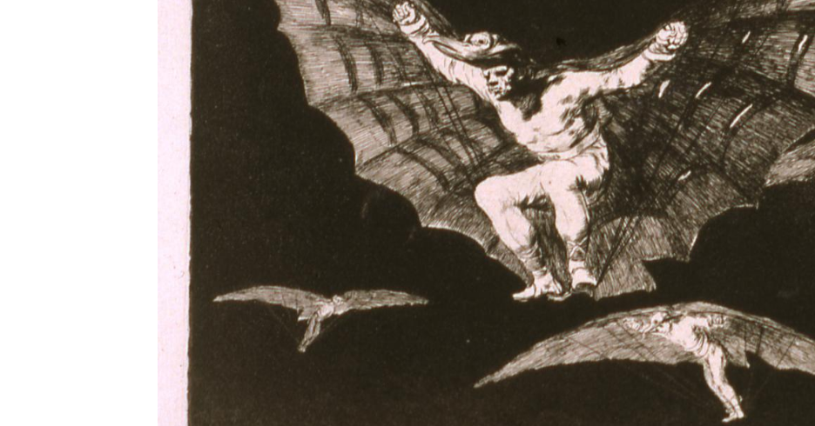
This piece was painted between 1746 and 1828. Goya was a Spanish royal court painter who sought to use his inventiveness and originality to depict the flying man. The painting that shows a male figure gliding through the air with huge wings was informed by various innovations that took place during that time. This includes the invention of hot air balloons. This artwork showcases the artist’s imagination. This piece has accomplished curator’s goal of depicting how artists used art to showcase their imaginations.
“Epifania” by Michelangelo
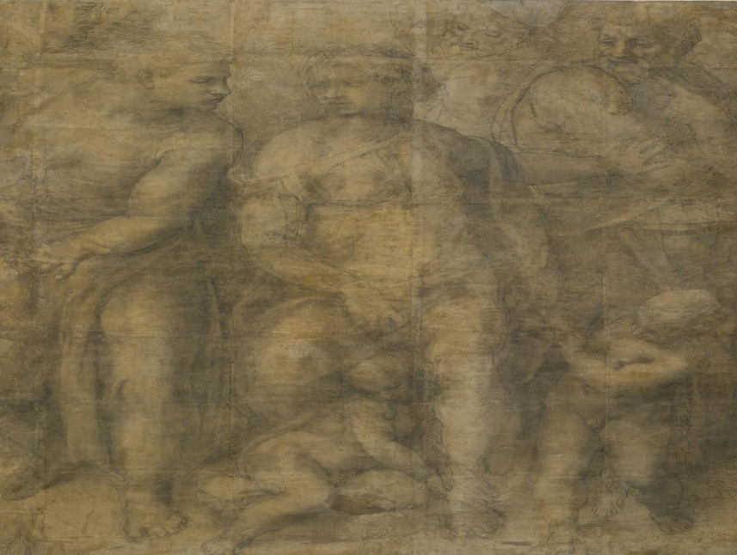
This artwork was produced between 1475 and 1564 (Bounarroti, 2020). Michelangelo was a Florentine Renaissance sculpture and painter and this was one of his few surviving pieces of art. The painting shows the virgin who engages in conversation with a gesturing man. On the right side, there is another man, believed to be St. John the Baptist who raises his arm and he is looking down at the child (Christ). This piece of art reflects the religious belief of the Renaissance period. This paint has been mistaken with the closely associated religious stories including the three wise men visiting Christ as well as Virgin Mary with John the Baptist. However, remains clear are that the painting reflected the religious Renaissance period. The painting has successfully depicted curator’s theme of how artists used art to showcase their imaginations. The painting has been confused and this confusion further reflects how artists like Michelangelo.
“Dancers practising at the Barre” by Edgar Degas
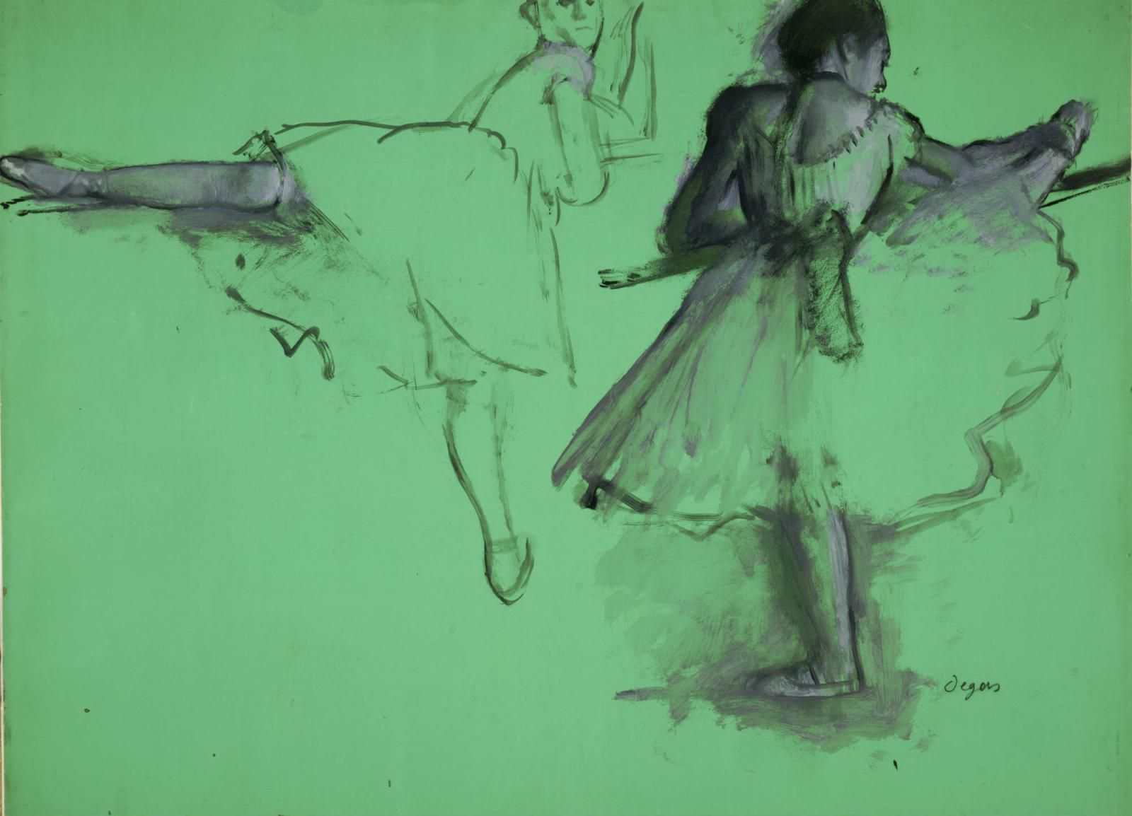
This piece was produced between 1834 and 1917. Currently, it is found in the British Museum in London. The painting shows ballet dancers performing on stage. The two dancers are different from each other. The upper dancer dances with a lot of vigour and speed, while the lower dancer seems dormant. Her leg is a lot more flexible than the second dancer (Stanberg, 2011). The second dancer may be waiting in the wings. Degas painting reflects the period when ballets performance at the Paris Opera was famous and common. This paint shows the artist’s exploration of the subject of the imagination of the ballet dancers on stage. This piece has also successfully showcased the curator’s goal of how artists used their imaginations to show things that they intimately experienced or had unguarded moments with.
From the above three pieces of paint and drawing exhibit from the virtual British Museum, London, we can get a glimpse of how useful the virtual museums have become in the current age of technology.
References
Bounarroti, M. (2020). “Epifania.” Arthive (online). https://arthive.com/michelangelo/works/508088~Epifania
Stanberg, S. (2011 November, 3). “Degas’ Dancers: Behind the scenes, at the Barre.” NPR (Online). https://www.npr.org/2011/11/03/141905600/degas-dancers-behind-the-scenes-at-the-barre

